Nama : Muhammad Lintang Pamungkas

NIM : 210103028

Kelas : 21 TIA1

Tugas Praktek

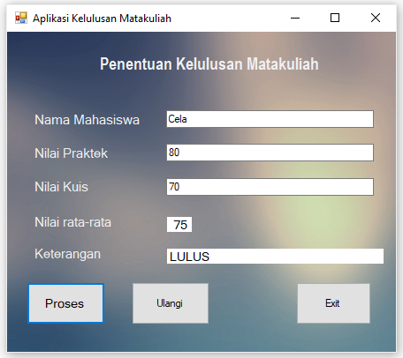Hasil Tampilan

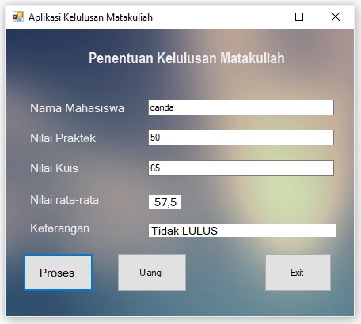

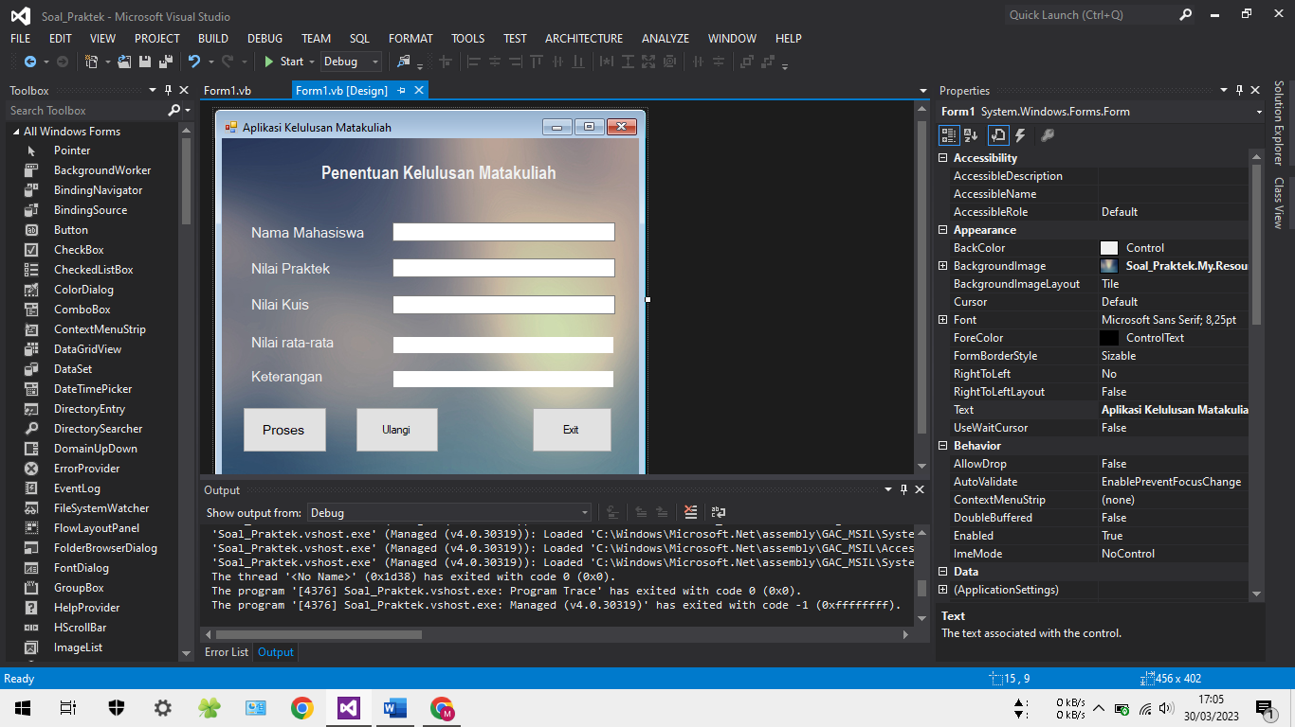Tampilan Microsoft visual studio

Source Code

|  |  |
| --- | --- |
| Button | Coding |
| Proses | Private Sub Button1_Click(sender As Object, e As EventArgs) Handles Button1.Click          Dim nilaip As Integer          Dim nilaik As String          Dim nilair As String          nilaip = CInt(nilai_p.Text)          nilaik = CSng(nilai_k.Text)          nilair = ((nilaik + nilaip) / 2)          rata_rata.Text = " " & nilair          If CInt(rata_rata.Text) >= 65 Then              keterangan.Text = "LULUS                                                "          Else              keterangan.Text = "Tidak LULUS                                    "          End If      End Sub |
| Ulangi | Private Sub Button2_Click(sender As Object, e As EventArgs) Handles Button2.Click          nama.Text = " "          nilai_p.Text = " "          nilai_k.Text = " "          rata_rata.Text = "                                                        "          keterangan.Text = "                                                        "          nama.Focus()      End Sub |
| Exit | Private Sub Button3_Click(sender As Object, e As EventArgs) Handles Button3.Click          End      End Sub |